A. La Rosa Lecture Notes
INTRODUCTION TO QUANTUM MECHANICS
PART- I The TRANSITION from CLASSICAL to QUANTUM PHYSICS
________________________________________________________________
Appendix-3 of Chapter 3
Light Scattering and Radiation Damping

3.1.B.b Light Scattering
Let
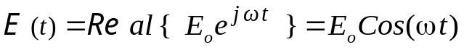 (22)
the time variation of the electric field of the incident radiation
Since the corresponding Poynting vector is given by 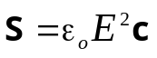, its average value is, according to (20),
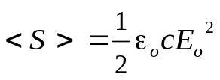 (23)
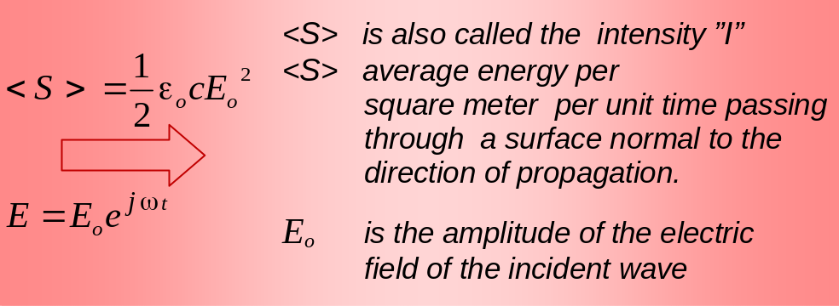
Fig. 3.9 Incident radiation of angular frequency 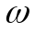.

When an atom characterized by a resonance frequency ω_{o}, is placed in a region where there is a bath of electromagnetic radiation, the radiation’s electric field 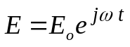 will drive the atom’s charge 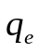 up and down; that is, it will accelerate the charge thus causing the atom to re-emit electromagnetic radiation. This process is called scattering. That is,
scattering is the process by which energy is
absorbed by an atom from the incident radiation (24)
field and re-emitted in all directions.
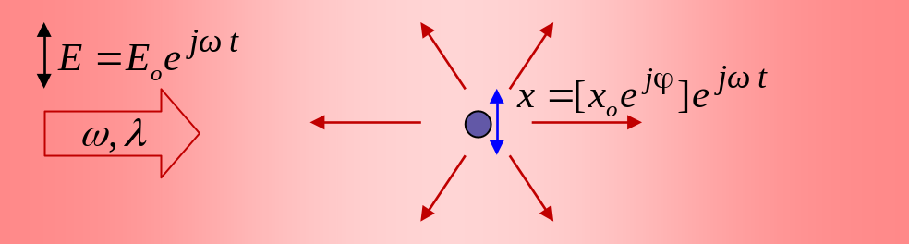
Fig. 3.10 Incident light is absorbed and (re-emitted) scattered by an atom.
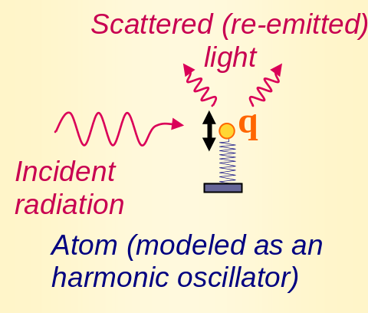
- Let’s calculate how much energy is scattered by the charge under oscillatory motion
The answer has actually already been given in expression (21) above, except that we need to find out the amplitude of oscillation 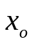, which will depend on the electric field amplitude of the incident radiation. For that purpose, let’s consider the equation of motion for the charge,
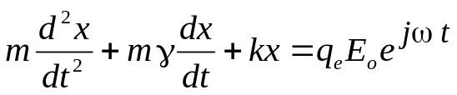 (25)
Here the term 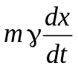 account for the presence of a dissipation energy source, which, in our case, is identified in the fact that the oscillator looses energy due to the electromagnetic radiation by the accelerated charge (it is chosen proportionally to the velocity just to facilitate the solution of the equation).
A stationary solution of (25) is
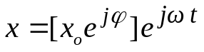 (26)
where
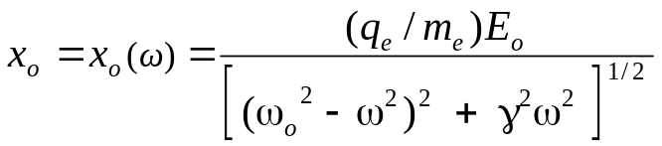 (27)
and
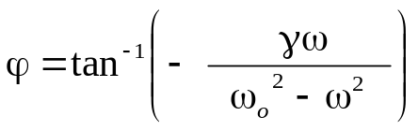 (28)
Expression (27) indicates that the amplitude of oscillation 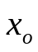 (and hence the acceleration) of the charge depends on the incident radiation’s frequency.

Notes on electromagnetic radiation damping: We make a parenthesis here to address the fact that the parameter 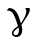, that appears in (25) as the factor that characterizes the dissipation of energy 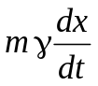 , should therefore be compatible with expression (21) that gives the energy dissipated by the oscillator. How to connect these two expressions? The following two notes attempt to address this question.
Note 1: The amplitude given in expression (27) comes as a result of a) the input energy from the external electric field of amplitude 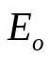, and b) the dissipation energy due to the fact that an accelerated electrical charge emits radiation; the latter is camouflage in the parameter 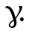
Note 2: Equation (25) contains the term associated to the dissipation of energy; that term should be consistent with expression (21) that gives the total dissipated energy. We should then be able to obtain an expression for by requiring that these two expressions be consistent with each other.
Indeed, on one hand, the power dissipate by a oscillator is given by forcexvelocity = [](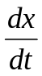) = [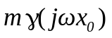](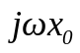) = =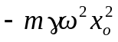. Here we have used the expression for 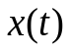 given in (26). The average value will be 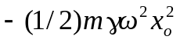
On the other hand, according to (21) the dissipated power is 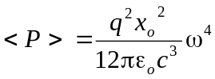
The last two expressions should be equal. This allows to identify 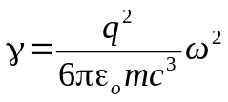 or, rearranging terms,
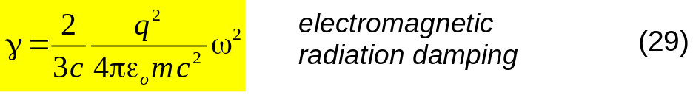

Let’s proceed now with our calculation of the total power radiate by the accelerated charge. If the expression (27) for is used in the expression for the radiation power 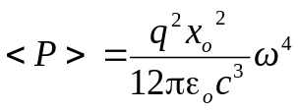 given in (21), one obtains, 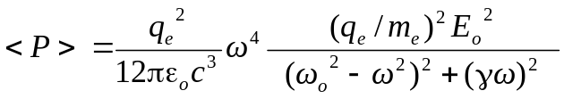, or, rearranging terms,
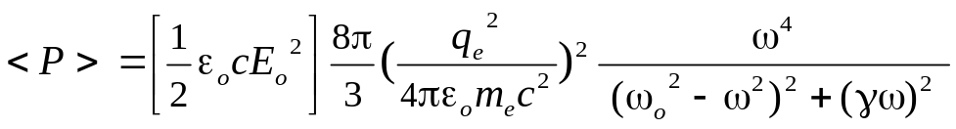 (30)
Out of the total incident radiation energy (characterized by its intensity 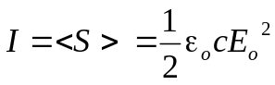), expression (30) gives the amount of energy that is absorbed and re-emitted by the oscillator.

Scattering cross section
If we considered a hypothetical cross section of area σ intersecting the incident radiation, the amount of energy per second hitting that area would be
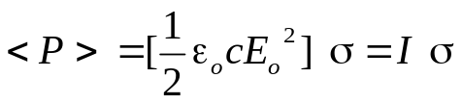 (31)
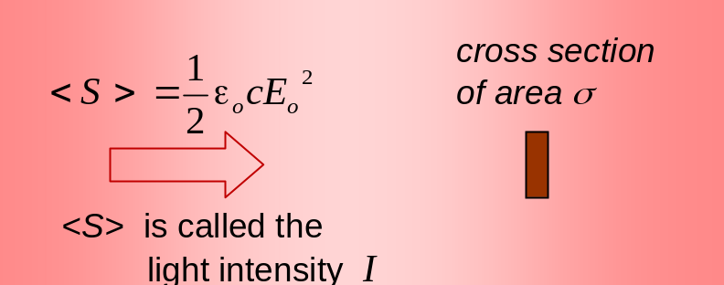
Fig. 3.11 Pictorial representation of scattering cross section.
One can use the analogy of an affective area being intercepted by the incident radiation to define how effectively the radiation is absorbed and (re-emitted) scattered) by an atom. In effect, comparing expressions (30) and (31), the total power scattered by an atom is numerically equal to the energy per second incident on a surface of cross-section area 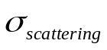, where
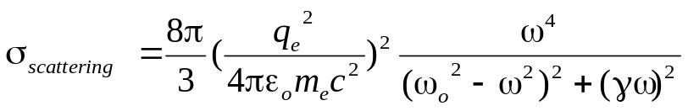 (32)
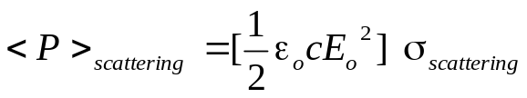 (33)

3.1.B.c Radiation Damping
Let
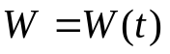 be the average energy of an oscillating (34)
charge at a given time .
If the oscillating charge is left alone to oscillate, its amplitude of vibration will die out progressively as the oscillator looses its mechanical energy by emitting electromagnetic radiation.
What fraction of its energy per second is lost?
How to associate an electromagnetic damping coefficient to this phenomenon (a damping coefficient similar to mechanical friction phenomena)?
Quality factor Q
One way to characterize damping phenomena is through the concept of the quality factor Q, which is defined as follows,
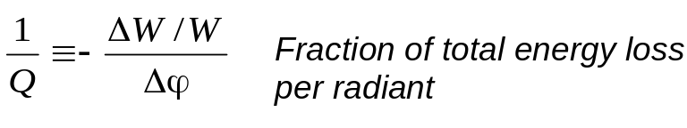 (35)
or, equivalently,
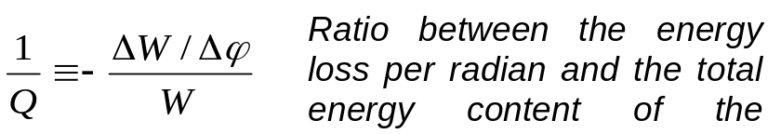

(This definition of Q applies for a very general class of dissipative processes, in particular to phenomena where the energy loss is associated to dissipative forces proportional to the particle’s velocity.)
In general Q depends on ω. But in the case of a damped oscillator left alone to damp its energy, the frequency of the damped oscillations is practically equal to the oscillator’s natural frequency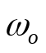 (unless Q is very low, in which case the use of Q is not very useful). Thus for a not very severely damped oscillator left alone to damped its energy, we have 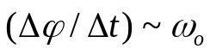 and thus, 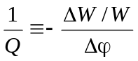= 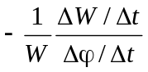, or
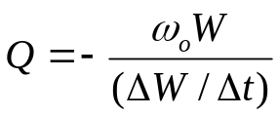 at 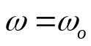 (36)
Assuming Q is constant, expression (35) implies 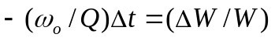 and 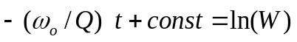, whose solution is,
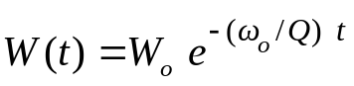 (37)
Alternatively, since the period of the oscillation is 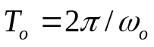 (where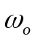 is the natural angular frequency of the oscillator), 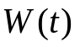 can also be expressed as,
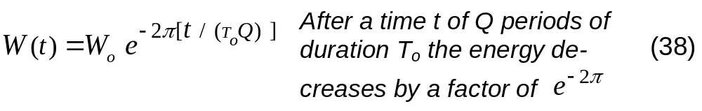
Calculation of the quality factor Q for electromagnetic damped oscillations
At any given time, the kinetic energy of the oscillator is 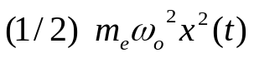; here 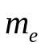 is the electron’s mass, and the frequency of oscillation is taken as . The average kinetic energy during one period of oscillations is 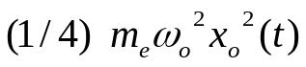(where is the amplitude at a given time.) The potential energy contributes with the same magnitude. Thus the average total energy during one period of oscillation is,
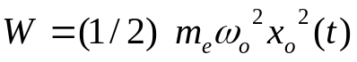 (39)
To evaluate (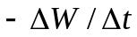) we use expression (21) with 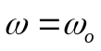, 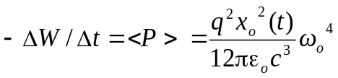 where one can factor out the value of  and obtain,
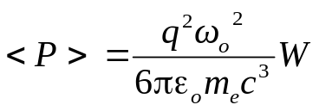 (40)
Using (39) and (40) in (35) gives, 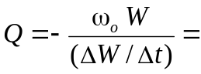 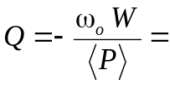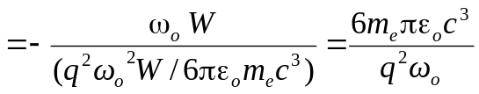. Rearranging terms one obtains,
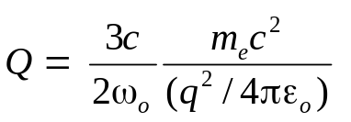 (41)

Notice, using the electromagnetic damping constant defined in (29) 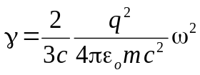 evaluated at one obtains,
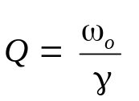 at (42)

In terms of 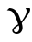, expression (35) can be rewritten as 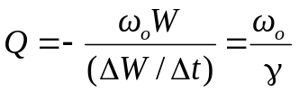 , or

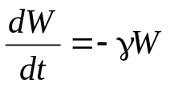 while oscillating at 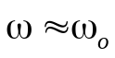 (43)
with its corresponding solution
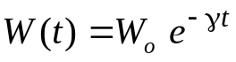 (44)

As an example, an atom that has a resonance frequency corresponding to λ= 600 nm, would have an quality factor of approximately,
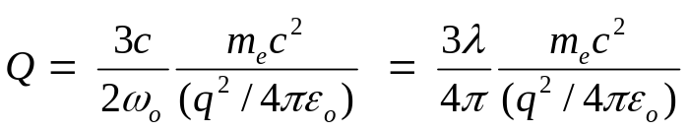

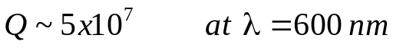 (45)
That is, the radiation will effectively dye out after ~ 10⁷ oscillations (~10⁻⁸ s.)

